AI Based Body Measurement App Prototype Documentation
Table of Contents
- Introduction
- Project Overview
- Features
- Technical Stack
- Folder Structure
- Key Components
- User Interface Design
- State Management
- Mock Services
- Conclusion
1. Introduction
The "AI Based Body Measurement App" is a mobile application developed using Flutter that allows users to register, log in, and take body measurements for clothing recommendations. The app employs a user-friendly interface, mock services for data handling, and provides a smooth navigation experience through various screens.
2. Project Overview
This app is designed for users seeking precise body measurements for clothing fitting. The app features registration and login screens, a category selection process, and options for manual or camera-based measurements. The results are displayed with recommendations for suitable clothing based on the measurements.
3. Features
- User registration and login
- Gender and height selection
- Manual and camera-based measurement options
- Mock services for handling user data and measurements
- Clothing recommendations based on measurements
- User-friendly interface with Material 3 design
4. Technical Stack
- Framework: Flutter
- State Management: Riverpod (flutter_riverpod)
- Routing: Go Router (go_router)
- Image Handling: Image Picker (image_picker)
- Design Language: Material Design 3
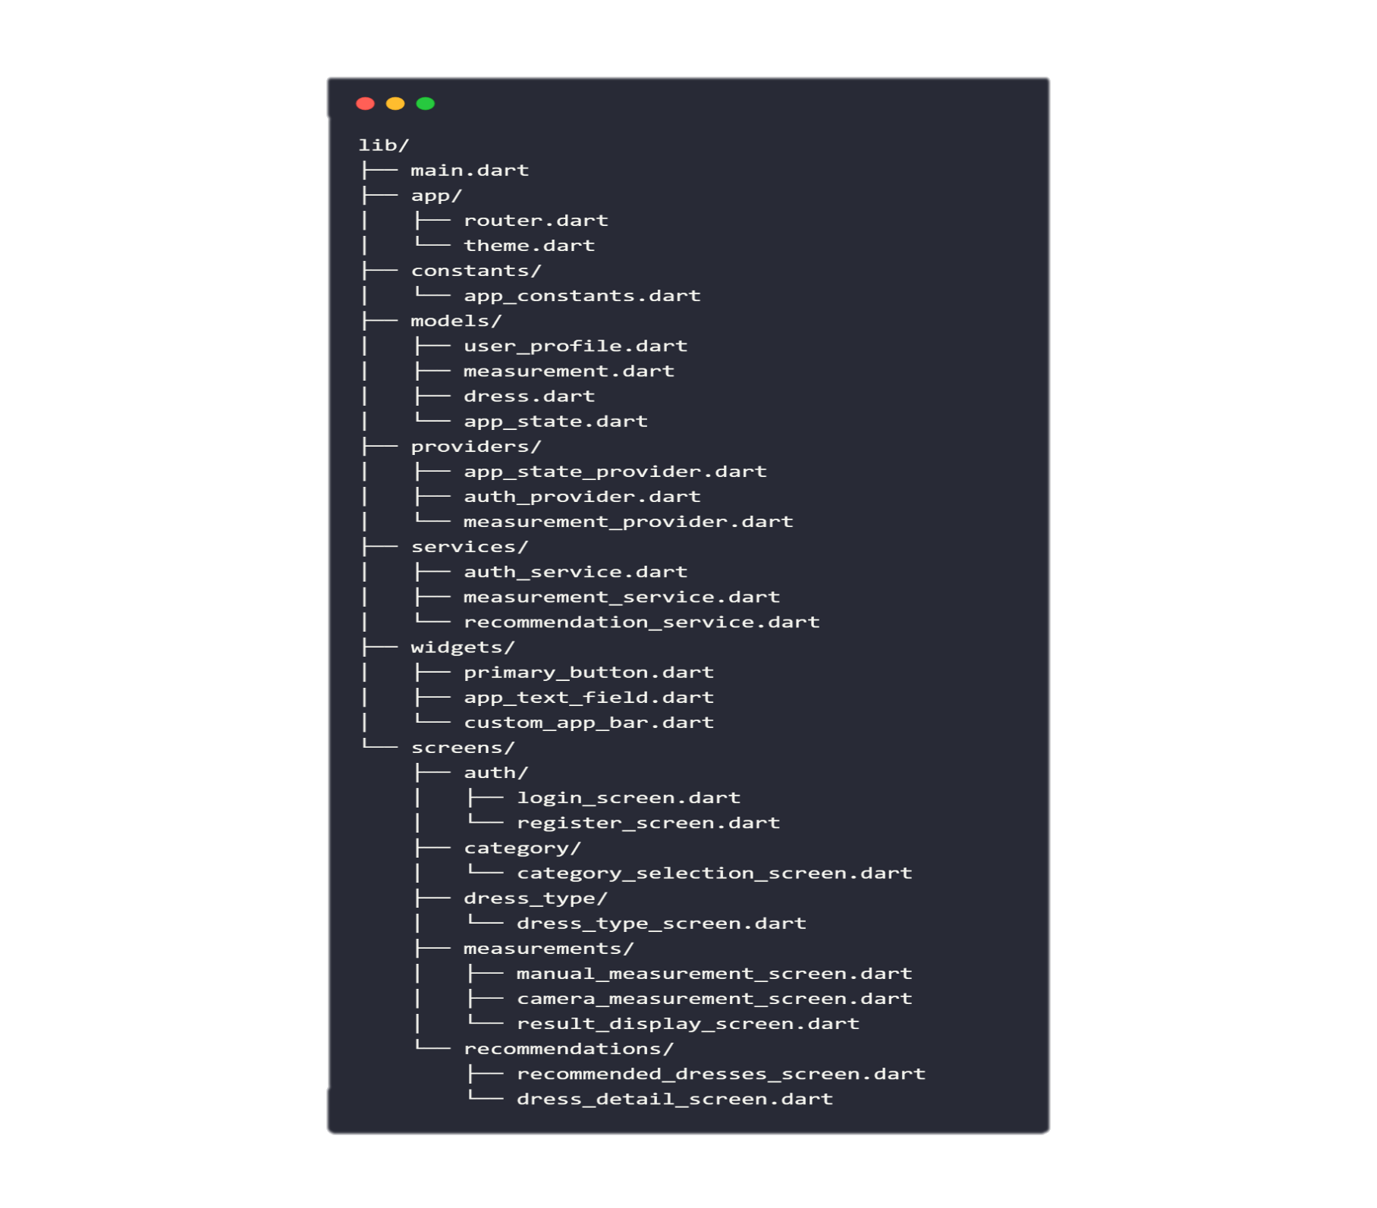
5. Folder Structure
The project follows a structured folder organization to separate concerns:

6. Key Components
Main Application Entry
- main.dart: Initializes the app, sets up the provider scope, and configures the router.
Routing
- router.dart: Manages the navigation between screens using named routes.
State Management
- app_state_provider.dart: Handles the app's global state, including user profile and measurements.
- auth_provider.dart: Manages authentication state and services.
- measurement_provider.dart: Handles measurement processing and results.
User Interfaces
- Screens: Each screen is separated into different files for login, registration, category selection, dress type selection, manual measurements, camera measurements, and result display.
- Widgets: Custom reusable widgets like PrimaryButton and AppTextField for consistent UI elements.
7. User Interface Design
The app follows a soft pink color scheme inspired by fashion apps. The UI is designed with Material 3 components, ensuring a responsive layout, consistent padding, rounded corners, and soft shadows for a modern look.
Key Screens
- Login Screen: Users can log in using email or phone with validation.
- Registration Screen: Users can create a new account with fields for personal information.
- Category Selection: Users select their gender category (Men, Women, Kids).
- Dress Type Selection: Users choose the type of clothing they want to measure.
- Manual Measurements: Users input measurements with a user-friendly interface.
- Camera Measurements: Users can take a photo for measurements.
- Result Display: Users view their measurements and recommendations.
8. State Management
The app uses Riverpod for state management. The AppState class is used to store user information, selected categories, and measurement results. The state is updated reactively, allowing screens to reflect changes automatically.
9. Mock Services
The app includes mock services for:
- Authentication: Simulates user login and registration.
- Measurement Processing: Simulates the calculation of measurements based on user input.
- Recommendations: Provides mock dress recommendations based on measurements.
These mock services are designed to facilitate future integration with a backend solution like Firebase.
10. Conclusion
The "AI Based Body Measurement App" is a comprehensive solution for users looking to find the right clothing fit through precise measurements. The app's architecture allows for easy expansion and integration with real backend services in the future. This prototype serves as a functional and visually appealing tool for body measurement and clothing recommendations.

